SB DCO Transition to Operations

Digital Client Onboarding (DCO) – Small Business
Digital Program

May 31, 2021

Contents
Digital Client Onboarding (DCO) – Small Business 1
Document Information 3
1. Revision History 3
2. Related Document References 3
Document Purpose 4
Service Overview 4
Stakeholders 5
Service Definition 8
People First Approach 8
Intake 8
Service Attributes 9
User Attributes 11
Known Defects / Issues 12
Access Request Details 12
Support Lifecycle 13
Transition (Hyper Care) Support Phase 13
Operational Support Phase 14
Operational Support Process Flow Diagram 14
Operational Support Teams 15
Sign-off 17
Appendix A – BCC Support Flow 19

Document Information

Revision History
Date | Authors | Revision Notes
April 6, 2021 | Andy Chawla  Chad Willsey | Initial Draft
April 13, 2021 | Chad Willsey | Revisions after SME review
April 19, 2021 | Chad Willsey | Revisions after business review
May 7, 2021 | Chad Willsey | Revisions after business review
May 31, 2021 | Chad Willsey | Approval of Document

Related Document References
Ref | Document Name | Short Description and URL
1.0 | Temenos Support Overview | CWB Support Introduction document located here

Document Purpose
The purpose of this document is to ensure the successful transition of new or changed service(s), service offering(s), or service option(s) to operational support. The contents of this document are to equip the operational support teams with the necessary knowledge, tools, and resources to effectively provide support for the service.

Service Overview
The deployment of the Temenos Infinity Digital Client Onboarding (DCO) Platform (aka. Temenos Avoka) will digitalize the existing and manual account opening processes for new CWBFG personal and small business clients. This includes webpage design, workflow management, analytical reporting, and user access setup on environments hosted on Temenos Cloud. The key goal of the Digital Program is to implement DCO processes and be a disrupter in offering unique online banking products and services for Personal, Small Business, and Commercial clients.
The first key project phase is DCO, which includes new front-end web pages (using Temenos Infinity) for prospective Business clients to enter their data and submit a request to open account(s) at CWB. A new back-end service facilitates account validations and the account creation in T24, without human intervention.
The first phase of the DCO release was Motive Friends and Family. The success of this release saw the program move forward with the next phase of the program: Personal (DCO Online and DCO In-Branch). This phase releases the DCO functionality to all CWBFG Personal customers, including the addition of allowing CWBFG Branch users to use the functionality to expedite the In-Branch Account Opening process. With the new release of Small Business Digital Client Onboarding (SBDCO), additional customers and CWBFG staff will be using the product, however the support structure for this release has only changed slightly. The Business Contact Centre (BCC) will be the support center for new to CWB small business clients using SBDCO Online. Branches using SBDCO In-Branch will continue to have the ability to:
- Revert to existing Account Opening procedures, when not using DCO, when issues are encountered; and/or
- Contact Help Desk or possibly the Branch & Client Support Centre (BCSC) directly for DCO issues.

Stakeholders
The following high-level diagram shows all the technical stakeholders of the DCO service:
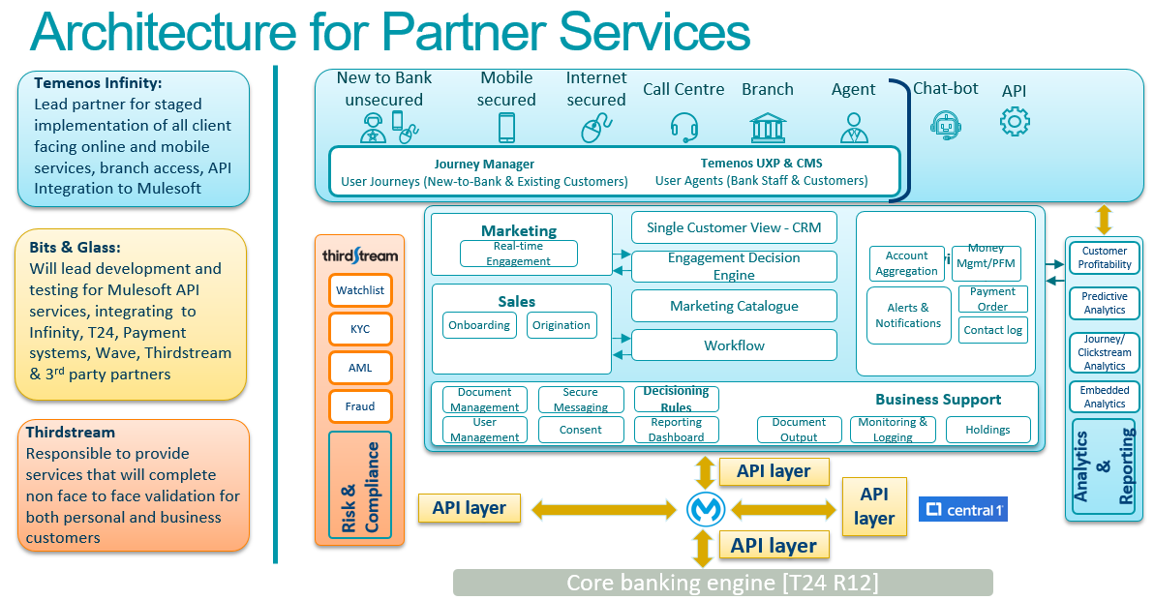

The following stakeholder list includes both internal and external (Vendor / Partner) contacts:
Name & Title | Role | Areas of Responsibility
Christina Mullin  VP, Digital & Alternative Channels | Service Business Owner | - Business owner accountable for the delivery of the service within agreed upon service levels
Jason Bond  Sr AVP, Application Services | Service Technical Owner | - Sr. Leadership accountable for the cost of delivering the service.
Stacy Schmidt  Head, Digital Delivery & Management | Service Business Partner | - Primary business department(s) IS would work with to deliver the service
Business Contact Centre (BCC) Team | Triage Analyst  (Tier I Initial Support) | - Intake of client support asks through SBDCO Online  - Perform initial support triage  - Escalate issues, as required, to Help Desk for additional triage and resolution  - BCC Team member to create incident or request in Buddy (Online Self-service Portal)
Help Desk | Tier 1 Support | - Triage and action received requests, as defined
Digital Technology Services (DTS) | Tier 2 Support | - Receives escalations  - Triage and action requests  - As required, escalate to other teams (internal and/or external)
Core Application Services (CAS) team | Tier 2 Support | - Receives escalations  - Triage and action requests  - As required, escalate to other teams (internal and/or external)
Identity Access Management (IAM) | Journey Manager Provisioning | - Receives Journey Manager access requests  - Provisions access to Journey Manager
Infrastructure Operations | Tier 2 Support | - Receives escalations  - Triage and action requests  - As required, escalate to other teams (internal and/or external)

Vendor Name | Contact information | Engagement Method | Service Levels & Considerations | Areas of Responsibility
Temenos | Lauren Wilson  lwilson@temenos.com | Enter Incident in Temenos Ticketing system:  https://support.avoka.com/  Hours of Operation  Monday to Friday  9:00 AM – 5:00 PM MST |  | Temenos supports:  - Journey hosting platform (SaaS Infrastructure)  - Maestro  - Journey Manager  - Journey Analytics
  Severity | Initial  Response | Updates
  1 | 15 min | Every 30 min (24/7)
  2 | 30 min | 1 hour
  3 | 1 business day | 1 business day
  4 | 2 business days | Weekly
Accutive | Accutive support team  Support@accutive.com  (949) 630-9568 Ext 4 | Email or phone for critical issues  Internal CWB TFS for non-critical issues |  | Journey Platform application support
  Severity | Initial  Response | Coverage
  1 | 15 min | 24/7
  2 | 30 min | 24/7
  3 | 1 business day | Standard Business Hrs
  4 | 2 business days | Standard Business Hrs
Bits In Glass | Andy LePage  andy.lepage@bitsinglass.com  (403) 399-6398 | Email or phone for support  Hours of Operation  Monday to Friday  8:00 AM – 4:00 PM MST | As required | MuleSoft application integration support
Third Stream | Darren Hycha  darren@thirdstream.ca  (587) 866-0510 | Email or phone Darren first for critical issues and then Enter Incident in Third Stream’s ticketing system (ActiveCollab)  https://app.activecollab.com  Hours of Operation  Monday to Friday  9:00 AM – 5:00 PM MST  Note: Only Authorized Personnel are permitted to enter tickets into ActiveCollab. The following people have been authorized for ticket entry:  - Mark Doubinin  - Brad Miller  - Brain Coghlan |  | Third Stream API integration support
  Severity | Initial  Response | Updates
  1 | 30 min | Hourly (24/7)
  2 | 60 min | Hourly (24/7)
  3 | 1 business day | As agreed upon
  4 | 2 business days | As agreed upon
MuleSoft | Andrew Coates, Client Success Manager  acoates@mulesoft.com  (416) 278 6442 | Create a Mulesoft Support Case ticket, in the Mulesoft Support Center, located at https://www.mulesoft.com/support-login  Hours of Operation  Monday to Friday  8:00 AM to 5:00 PM (local time) |  | MuleSoft platform and product support
  Severity | Initial  Response | Coverage
  1 | 2 hours | (24/7)
  2 | 4 hours | 8-5 MST
  3 | 8 hours | 8-5 MST
  4 | 8 hours | 8-5 MST

Service Definition

People First Approach
The People First (P1) Approach can be found here.

Intake
The intake and issue resolution process is as follows, noting that BCC will be the first point of contact for customer-facing challenges regarding SBDCO Online. Should Branch staff encounter challenges with SBDCO In-Branch, they will continue by using existing account opening procedures. Once the account is opened and the customer has left, the Branch staff will then be able to review their DCO challenges and directly engage CWBFG Help Desk to report the issue. Upon receipt, Help Desk will triage the issue and engage Tier II or Tier III, as necessary.
See appendix A for detailed task descriptions.

Service Attributes
Attribute | Description
Service Name | Digital Client Onboarding (DCO)  Phase 1: Motive Pilot (Motive Friends and Family)  Phase 2: Personal (Including full Motive & CWBFG Friends & Family, followed by Canada-wide release for full Personal)  Phase 3: New service for Small Business DCO
Service Offering(s) | Both BCC and branch staff will require to report DCO issues brought forward by/for business customers. The following requests have been built for this release of the Digital Customer Onboarding program:  - Staff will have access to a new Buddy request to submit DCO In-Branch issues*  - Staff will have the capability to request access to Journey Manager/Workspaces **  Additional offerings may be identified as part of the Service’s Continual Service Improvements (CSI) review.  *If the Buddy request has not yet been implemented, staff will submit a “Report an Issue>>Contact IS” request detailing their experience.  ** If the Buddy request has not yet been implemented, staff will submit a “Report an Issue>>Contact IS” request detailing the access they are requesting.  The existing SLA response time of 60 minutes to turn the Buddy request into an incident ticket will apply to the SB DCO as well.
Delivery Methods | Incidents: When customer initiated: BCC staff will perform initial DCO root cause analysis (RCA) for issues encountered within the DCO process. Complex and/or time-consuming issues are escalated to Help Desk for further triage and resolution.  Incidents: When Branch initiated: Should Branch staff encounter issues while using the DCO, they will revert to current processes (manual) to onboard the customer. Once completed, the Branch staff will then document the DCO issue by submitting directly to the CWBFG Help Desk, by phone, email or Buddy Request (In Buddy: Report an Issue>>Digital Customer Onboarding (DCO) Issue*). Upon receipt, Help Desk for further triage and resolve the issue.  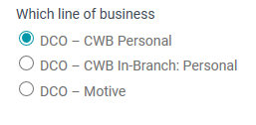  *If the lines of business DCO – Small Business or DCO – Small Business In-Branch has not yet been implemented within the Buddy Request, staff will submit a “Report an Issue>>Contact IS” request detailing their experience.  Journey Manager/Workspaces Access Request: Staff who requires access to Journey Manager or Workspaces will be able to request access using a Buddy request (Service Catalog>>Access Requests>>Journey Manager or Workspaces Access**).  ** If the Buddy request has not yet been implemented, staff will submit a “Report an Issue>>Contact IS” request detailing the access they are requesting.
Service Availability | Production Links:  Links for DCO Small Business and CWBFG Branch (In-Branch Method) will be published on INFOserver closer to Go Live  The DCO Service itself is available 24/7/365, however support is only available during support hours, uniquely defined by support group.
Internal Support Availability | Tier I: BCC Support  Hours of Operation:  Monday to Friday 7:00AM – 7:00PM Mountain Standard Time (MST)  Saturday 9:00AM – 4:00PM Mountain Standard Time (MST)  FYI – Initial Rollout hours contingent on staffing levels and capabilities  Contact Method(s):  Phone: 1 -833-292-2265 (1-833-CWB-BANK)  Email: Business-onboarding@cwbank.com  Tier II Help Desk (typically ONLY engaged by Tier I escalation):  Hours of Operation:  Monday to Friday 6:00AM – 6:00PM Mountain Standard Time (MST)  Contact Method(s):  - Buddy requests (Self Service)  - Email: helpdesk@cwbank.com  Urgent issues: 1 (844) 441 2248, Option 1  Escalated Incident ticket from Service Now Tier I team.  Tier II Digital Technology Services (DTS) Team:  Hours of Operation:  Monday to Friday 8:00 AM to 4:30 PM Mountain Standard Time (MST)  Contact Method(s):  Escalated Incident ticket from Service Now Tier I team.  Tier III – Varies  Hours of Operation:  Various*  *See Vendor Support Availability Section  The current IS SLA response times will also apply to incidents raised for the SB DCO.  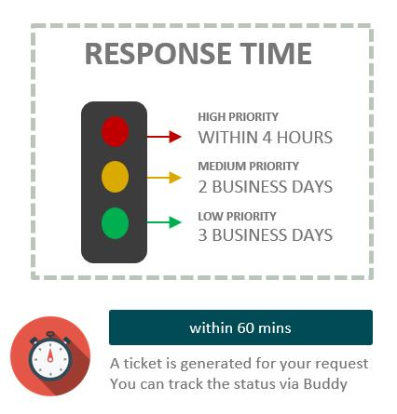
Vendor Support Availability | Varies, by Vendor. See Stakeholder section
Service Capacity | Thousands of Records generated through the SBDCO
Service Level Agreement | See Vendor section.
Service Costs | See Vendor section.
Service Maintenance and Updates | Temenos Journey Platform:  - Major product releases every 6 months  - Minor product updates once per month  Vendor Updates:  - As required, will use CWB change management processes to deploy production updates.
Service Criticality | Non Critical Service, no SLA targets if service is offline.
Service dependencies and prerequisites | The following dependencies have been identified as having an integration point with this service:  - T24 – Banking system of record  - Network Service – Communications to/from external services/APIs  - Internet Service - Communications to/from external services/APIs
Intended Audience | The Intended audience of this service is small business CWBFG customers to allow for customers to open their accounts.  This service will used be used to expedite the in-branch account opening process. CWBFG Branch staff will now use the service to open customer’s accounts.

User Attributes
Attribute | Description
Business Users | This service is currently available to only CWBFG Business customers and CWBFG Branch staff
User Prerequisites | New to CWB customers may be able to use this service.
Service Request | Service will be available through the new online banking platform. Any issues encountered will be supported by the BCC Support team (customers) and Help Desk (Branch staff).
Access Request(s) | IAM will provision Journey Manager and Workspaces access via a Buddy Access request. All access requests will need to be approved by the Branch/Department Manager as well as the Manager of Alternative Channels.
Service Support | Should business customers encounter issues with the DCO service, they can contact BCC Support, during support hours, for resolution/investigation. No after-hours support is provided at this time.

Known Defects / Issues
At Go Live, a list of the most impactful defects will be published on INFOserver. Updates and workarounds concerning these defects will be published in frequently asked questions that will be available to the users in materials like Your Connection and Digital Program News.
The following reports currently being utilized for the first two phases of the DCO will also be utilized for the reporting of issues that was raised for the SB DCO to determine any trends or common recurring issues.
- DCO status report
- Digital incidents created w/out Motive tickets.
- Digital incidents closed within the past 7 days.

Access Request Details
Fulfillment Team | Scope of Activities | Contact Channel(s)
IAM | Fulfilling Journey Manager / Workspaces access requests will be the responsibility of the IAM team.  All Journey Manager access requests are to have multiple levels of approvals.  - First level is the branch manager.  - Second level is the Manager of Alternative Channels (Michael White) | ServiceNow application via Buddy or help desk

Support Lifecycle
The Support Lifecycle is divided between Transition (during go-live) and Operation (post go-live/regular support).
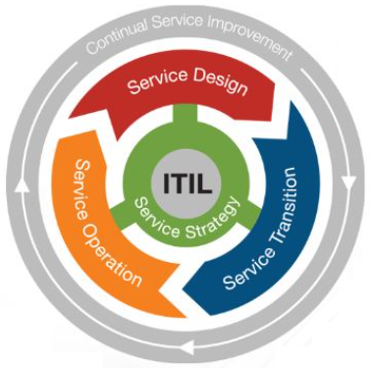
Most services require an enhanced support model during the Transition period, also known as “Hyper Care”. As the name implies, support levels during the transition phase are typically heightened to provide rapid response and resolution of incidents related to the new service. Hyper Care remains in place until the Hyper Care Exit Criteria is met (noted below), upon which time the support of the DCO service will move to the Operational support model. Support in the Operational phase is meant to provide typical day-to-day support, often within the existing standard Help Desk Service Level Targets.

Transition (Hyper Care) Support Phase
Not required.
Hyper-care / Stabilization Process Flow Diagram – N/A
Hyper-care / Stabilization support schedule – N/A
Hyper-care / Stabilization Support Team – N/A
Hyper-care Exit Criteria – N/A

Operational Support Phase

Operational Support Process Flow Diagram
See appendix A for detailed task descriptions.

Operational Support Teams
The following are areas of support, including escalation triggers, for support of the DCO Service during the Operational phase of support.
Support Level | Support Team | Scope of Support | Support Channel(s)
Tier 1 | BCC | All issues encountered by the business DCO Online service are sent to Business-onboarding@cwbank.com for initial investigation and triage.  When the root cause cannot be determined, OR is not within the scope of support, BCC Support will create the appropriate request for Help Desk to triage.  !Note: BCC will submit the request with “Guest” as the “Requested For” since the issue was reported by our clients. | - BCC can be contacted via:  - Phone: 1-833-292-2265, or  - Email: Business-onboarding@cwbank.com  - BCC support will initiate the incident  - BCC Support will perform RCO to determine routing/triage activities and action accordingly.
Tier I | Branch Staff | When issues are encountered, branch staff will continue opening the account for the customer, reverting to existing/current methods.  Once the account is open, and customer has left, Branch will notify Help Desk of the issue so it can be logged and investigated. | Submit request by phone, email or Buddy Request (In Buddy: Report an Issue>>Digital Customer Onboarding (DCO) Issue*). Upon receipt, Help Desk for further triage and resolve the issue.  *If the Buddy request has not yet been implemented, staff will submit a “Report an Issue>>Contact IS” request detailing their experience.
Tier 1 | Help Desk | Upon receipt of the DCO Support, Help Desk will evaluate the request to identify routing, from Tier II triggers, or immediate actioning. | If Help Desk Resolves:  - Resolve the request by resolving the issue.  !Note: Service Now will notify the Requestor of the ticket closure.  Escalate to another team:  - Transfer the ticket to the Tier II team (e.g. Digital Technology Services (DTS) team)
Tier I | IAM | Upon receipt of an APPROVED Journey Manager or Workspaces access request, IAM will work with the requestor to set up their permissions (including Multi-Factor authentication) | Users who require Journey Manager or Workspaces access will use a new Buddy request (Via Buddy: Service Catalog>>Access Requests>>Journey Manager or Workspaces Access*)  * If the Buddy request has not yet been implemented, staff will submit a “Report an Issue>>Contact IS” request detailing the access they are requesting.
Tier 2 | All | Upon receipt of an escalated DCO request, the tier II team will:  - Evaluate the issue  - Perform Root Cause Analysis to:  - Resolve the issue & close the request, OR  - Engage additional teams/vendors for escalated support. | Work to resolve the incident, engaging additional vendors as required. Upon successful resolution:  - Resolve the Incident, outlining any resolution activities  - Resolving the Incident will trigger an email to the BCC Support person, who can then follow-up with the customer and perform any resolution activities required.  !Note: Standard Information Technology Infrastructure Library (ITIL) processes will be used for Incident Escalation and resolution, including production deployments.

Sign-off
Name & Title | Date of Sign-off | Approval Email | Digital Sign-off
Michael White  AVP & Manager, Alternative Channels | May 18, 2021 |  | ☒
Francis Ho  AVP, Small Business Banking, Digital & Alternative Channels | May 7, 2021 |  | ☒
Chantel Butt  Senior Manager, Organizational Change Management | My 7, 2021 |  | ☒

THIS PAGE IS INTENTIALLY LEFT BLANK

Appendix A – BCC Support Flow
Process  Step | Step Name | Step Description | Role | Discussion Points
 | BCC Support is contacted, via email or phone for DCO support. | The purpose of this step is to trigger the DCO support process.  The outcome of this step is the identification of a DCO issue. | BCC
10 | BCC Triage | The purpose of this step is to perform initial triage, and potential resolution, of a reported DCO issue.  The outcome of this step is successful identification of a support request. | BCC | The use of known issues, workarounds and FAQ documentation will guide BCC to the support activities required to resolve or escalate the issue.  Applicable customer scripting as/if required.
15 | Resolve or Escalate? | Determine if the request requires further actioning or can be resolved. | BCC
20 | Resolve | The purpose of this step is to resolve the DCO issues, without escalation.  The outcome of this step is successful resolution of the issue. | BCC | This is also known as "First Call Resolution".
 | End | Once the issue has been resolved, the BCC ticket will be closed. | BCC
30 | Engage Help Desk | The purpose of this step is to engage the Help Desk team for further triage activities.  The outcome of this step is successful engagement of the Help Desk team. | BCC | In Service Now, BCC will have a customized form to track DCO service issues. Upon verification of the need for Tier II RCA, BCC will escalate by creating a formal Incident for the Help Desk team. This process will be automated by a button and will:  1. Create an Incident, transferring ticket details from the BCC request to the Incident  a.) Requestor will be the BCC Support person who created the Incident  b.) Requestor will be able to monitor the progress in Buddy  2. Assign the Incident to the Help Desk team for triage, which formally initiates the standard CWB ITIL Incident process(es).  3. Upon completion of the Incident, the BCC Support person will receive a Service Now notification that their incident has been resolved.  a.) BCC can test the resolution (if required); if not working can REOPEN the Incident (in Buddy) for the Tier II team(s) to investigate further, or  b.) BCC can then notify the customer of the resolution and close their request.
 |  | Upon successful initiation of the Incident, BCC Support person will receive a notification, from Service Now, outlining the Incident ID and ticket details. BCC Support can follow the progress of the Incident in Buddy.  Upon successful assignment of the Incident to the Help Desk, Service Now will send an email to Help Desk to notify them of the incoming incident.
  Notification
 | Issue Encountered | To trigger the InBranch Support process, the branch must encounter a DCO issue. | Branch Staff
150 | Finish Onboarding | The purpose of this step is to complete the account opening using current processes (non-DCO).  The outcome of this step is to have accounts opened for the customer. | Branch Staff | Branch will complete the account opening, to get the customer on their way. Once complete, the issue will then be reported.
155 | Initiate Incident | Determine method to submit DCO issue to Help Desk | Branch Staff | Use the new Buddy request found in:  Report an Issue>>Digital Customer Onboarding (DCO) Issue  Note: Recommendation is to use Buddy request over calling Help Desk.
160 | Create Buddy Request | The purpose of this step is to fill out the DCO Issue request, identifying the issues encountered while using the service.  The outcome of this step is a DCO Incident is raised. | Branch Staff
 |  | Upon successful initiation of the Incident, Branch person will receive a notification, from Service Now, outlining the Incident ID and ticket details. Submitter can then follow the progress of the Incident in Buddy.  Upon successful assignment of the Incident to the Help Desk, Service Now will send an email to Help Desk to notify them of the incoming incident.
  Notification
40 | Triage | The purpose of this step is to determine the root cause of the issue.  The outcome of this step is to determine next steps, as a result of the root cause analysis. | Help Desk
45 | Resolve or Escalate? | Determine if the request requires further actioning or can be resolved. | Help Desk
50 | Engage Tier II | The purpose of this step is determine the engagement method of the next Tier.  The outcome of this step is the successful support engagement of the DDT team, or other team(s), required to resolve the Incident. | Help Desk
 |  | Upon successful assignment of the Incident, the assigned Support Team will be notified, via email, of the Incident.
  Notification
60 | RCA  Root Cause Analysis | The purpose of this step is to determine the root cause of the issue.  The outcome of this step is to determine next steps, as a result of the root cause analysis. | DDT  (Digital Delivery Team)
65 | Resolve or Escalate? | Determine if the request requires further actioning or can be resolved. | DDT  (Digital Delivery Team)
70 | Escalate | The purpose of this step is determine the engagement method of the next Tier.  The outcome of this step is the successful support engagement of other team(s) required to resolve the Incident. | DDT  (Digital Delivery Team) | The DDT will own the engagement of other vendors/teams. They will work with the teams to ensure CWB methodology is followed (ITIL).
 |  |  | DDT  (Digital Delivery Team)
  The formal engagement of other teams, which may be internal or external to CWB.
80 | Tier III RCA | The purpose of this step is to determine the root cause of the issue.  The outcome of this step is to determine next steps, as a result of the root cause analysis. | Tier III
90 | Resolve | The purpose of this step is resolve the issue.  The outcome of this step is the resolution required to fix the issue | Tier III | Once the resolution has been found, the DDT will work with Tier III to resolve the issue.
 |  |  | DDT  (Digital Delivery Team)
  Notification of resolution to the DDT.
100 | Confirm Resolution | The purpose of this step is to confirm the resolution provided by Tier III.  The outcome of this step is that the resolution required to fix the issue is identified and communicated back to the DDT. | DDT  (Digital Delivery Team) | Should any resolutions provide by the Tier III team not prove effective, the DDT will work with the Tier III(s) to further investigate and resolve the issue.
105 | Change Required? | Determine if a production change is required. | DDT  (Digital Delivery Team) | CWB Standard Operating Procedures will be used to introduce changes to the CWB Production environment(s).
110 | Resolve | The purpose of this step is resolve the issue.  The outcome of this step is the issue is fixed. | Tier III
115 | Initiated by? | Determine who should be notified of the resolution: BCC or Branch Staff | Help Desk | Let the submitter know the issue has been resovled. Submitter can review & reopen the ticket (in Buddy) if the issue is not resolved.
120 | CWB Change Management SOP | The DDT will work with the support teams to implement the fix to resolve the issue using existing ITIL Change and Release Management processes. | DDT  (Digital Delivery Team)
130 | CWB Release Management SOP |  | DDT  (Digital Delivery Team)
 |  | Upon successful resolution of the Incident, BCC Support person will receive a notification, from Service Now, outlining the Incident resolution details. BCC Support can test the proposed solution, if needed. BCC will be able to reopen the Incident, should the resolution provided NOT resolve the issue.
  Notification
140 | Customer resolution | The purpose of this step is notifying the customer and action any resolution activities identified.  The outcome of this step is the customer has been notified their issue has been resolved. | BCC | BCC Support owns the relationship with the customer.
 | End |  |  | Service Now Incident is closed, by DDT (including associated vendor tickets)  BCC Request is closed  Customer's issue has been resolved

